A MINI PROJECT REPORT

ON

“Classification of Diabetes”

Submitted to

SAVITRIBAI PHULE PUNE UNIVERSITY

in completion of
LABORATORY PRACTICE - II
(B.E. Computer Engineering)

BY

Name of the student: Aniruddh Bhagwat Roll No : 405B005
Name of the student: Manav Chouhan Roll No : 405B018
Name of the student: Rohit Kshirsagar Roll No : 405B036
Name of the student: Prashant Kumar Roll No : 405B049



Department of Computer Engineering
Sinhgad College of Engineering, Pune-41
Accredited by NAAC with grade ‘A’

YEAR 2020 - 2021

CERTIFICATE

Sinhgad Technical Education Society,
Department of Computer Engineering
Sinhgad College of Engineering, Pune-41
Accredited by NAAC with grade ‘A’

“Classification of Diabetes”

Submitted to

SAVITRIBAI PHULE PUNE UNIVERSITY

in completion of

LABORATORY PRACTICE - II
(B.E. Computer Engineering)

BY

Name of the student: Aniruddh Bhagwat Roll No : 405B005
Name of the student: Manav Chouhan Roll No : 405B018
Name of the student: Rohit Kshirsagar Roll No : 405B036
Name of the student: Prashant Kumar Roll No : 405B049

Prof. U. A. Mande Prof. K. B. Satpute
Internal Guide External Guide
Department of Computer Engineering Department of Computer Engineering

Prof. M. P. Wankhede Dr. S.D. Lokhande
Head of Dept. Principal
Department of Computer Engineering SCOE, Pune

CONTENTS

TITLE PAGE NO

Certificate I
Acknowledgement II
Abstract III

- INTRODUCTION

  - Background And Basics
  - Purpose
  - Motivation

- PROJECT PLANNING & MANAGEMENT

  - Software and Hardware requirement
  - Literature Survey
  - Proposed System

- IMPLEMENTION & CODING

3.1 Methodology
3.2 Graphical User Interface Design

- ALGORITHM

4.1 K-Nearest Neighbour
4.2 Naïve Bayes

- TESTING

- CONCLUSION

- REFERENCES

ACKNOWLEDGEMENT

We take this opportunity to express our profound gratitude and deep regards to our guide Prof. U. A. Mande and Prof. K. B. Satpute for their exemplary guidance, monitoring and constant encouragement throughout the course of this thesis. The blessing, help and guidance given by them time to time shall carry us a long way in the journey of life on which we are about to embark.

We are obliged to staff members of SCOE for the valuable information provided by them in their respective fields. We are grateful for their cooperation during the period of our assignment.

Lastly, we thank almighty, our parents and friends for their constant encouragement without which this project would not be possible.

ABSTRACT

Several chronic diseases have affected the human health in the recent times. Many diseases are widespread and caused severe damage on the mankind. The technological advances have proved most of the diseases can be cured in this medical era, but certain diseases can only be prevented but not cured, one among them is diabetes.

In this project , we report a medical case by considering electronic health records of diabetic patients from various sources. The analyses are carried out using two data mining classification algorithms such as Naive Bayes and K-Nearest neighbour. The aim of the analysis is to predict diabetes using health record and compare the accuracy of these two algorithms to find a better algorithm for predicting diabetes.

Also, after integrating system with html pages by using Flask framework, the testing is done. Unit testing and Web-based testing i.e. Selenium Testing is applied as a part of testing.

INTRODUCTION

  - BACKGROUND AND BASICS

Health care is one of those fields in the modern times which generates large amount of data. These data’s if used technically in a better way can produce significant outcomes in research and engineering. The records which are just patient information in the hospitals can be transformed into more useful data in data mining. Diabetes is one of the most hazardous chronic diseases. The presence of glucose in the blood of a person regulates the body metabolism. If the glucose is too low it is termed as low glucose level in blood, likewise if it is high, blood is said to have high glucose levels, but having high glucose levels to a prolonged period stimulates the liver not to produce enough insulin that regulates glucose level in blood this is called as diabetes mellitus, simple diabetes

  - PURPOSE

The main purpose of this system is to provide more accurate result of Classification of Diabetes. The data mining algorithm used is Support Vector Classifier.

1.3 MOTIVATION

- Lifestyle: Due to current working scenarios primarily in corporate sector, the lifestyle of people have become quite sedentary, involving minimum physical activity. Due to such inactiveness there is high risk of various diseases including diabetes.

- Prediction: As the saying goes, “Prevention is better than cure!” it is always better to predict the disease in advance and act accordingly. Early Prediction can prevent adverse effects.

- Technology: By using latest technology and machine learning algorithm prediction of diabetes can be very effective. Technology can be a reliable and efficient tool.

PROJECT PLANNING & MANAGEMENT

2.1. HARDWARE AND SOFTWARE REQUIREMENTS

- Python Version 2.7.x or above .
- Operating system : Windows 7 and Later, Linux , MacOS .
- A good integrated development environment(IDE) .
- Following python libraries –
- Seaborn
- Flask
- Numpy
- Pandas
- Matplotlib
- Sklearn

2.2. LITERATURE SURVEY

Dursen Delen et al. work discusses on predicting breast cancer using data mining methods like artificial neural network, decision tree and logistic regression. The result of this work concludes that decision tree is more accurate than the rest. Jothi et al. work focuses on predicting heart disease using k-nearest neighbor, decision tree and naïve Bayes. It is found that naïve Bayes predicted accurately compared to k-NN and decision tree. Similarly kidney disease prediction is also carried out using KNN algoritm and Naïve Bayes method and result shows that KNN algoritm is better than Naïve Bayes. The above related work shows that KNN algoritm and Naïve Bayes methods tends to provide quite accurate prediction results as compared to other methods.

2.3. PROPOSED SYSTEM

Our aim is to develop software system that predicts the whether given values indicate diabetes or not By using Data Mining algorithm like KNN algoritm and Naive Bayes algorithm we have trained the data.

IMPLEMENTATION AND CODING

3.1 METHODOLOGY
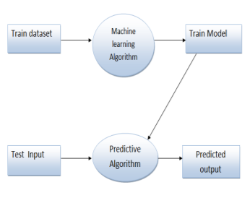
Fig. 3.1. Methodology

- Train Dataset: A training dataset are the examples used for learning to create a model. These are used to train the algorithm to produce the required outcome.

- Machine Learning Algorithm: K-Nearest neighbour and Naïve Bayes algorithms are used to train the model using training data set.

- Train Model: It includes training a model using machine learning algorithm with training data. The model refers to the outcome of the ML algorithm with the training dataset.

- Test Input: The data specifically identified for use in test is the test input data. Typically test input is used to verify that a given set of input produces some expected result. The accuracy of the result depends on the trained model for the test input.

- Predicted Output: It is the result of predictive algorithm which predicts, whether the input data has diabetes or not. After getting prediction probability of these two machine learning algorithms for given sample diabetic datasets, prediction efficiency of these two are compared to determine the efficient algorithm in predicting sample datasets.

3.2 GRAPHICAL USER INTERFACE DESIGN

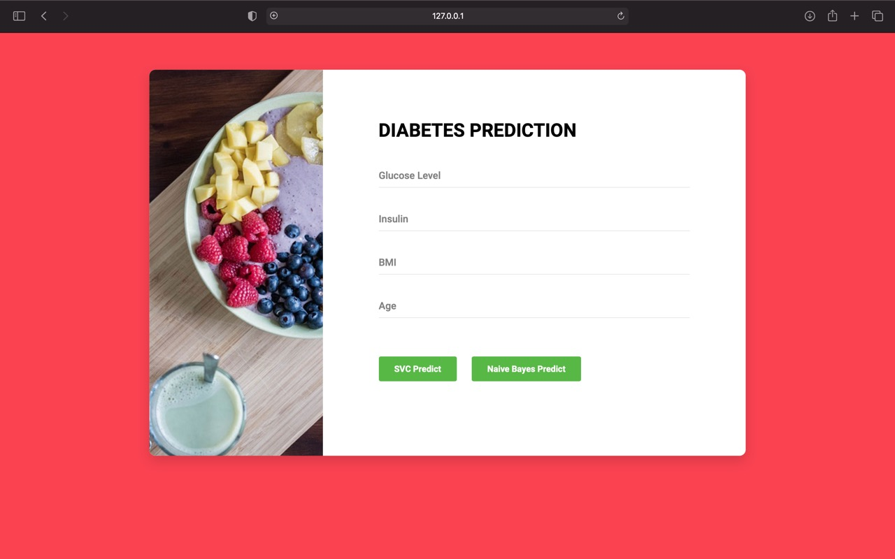

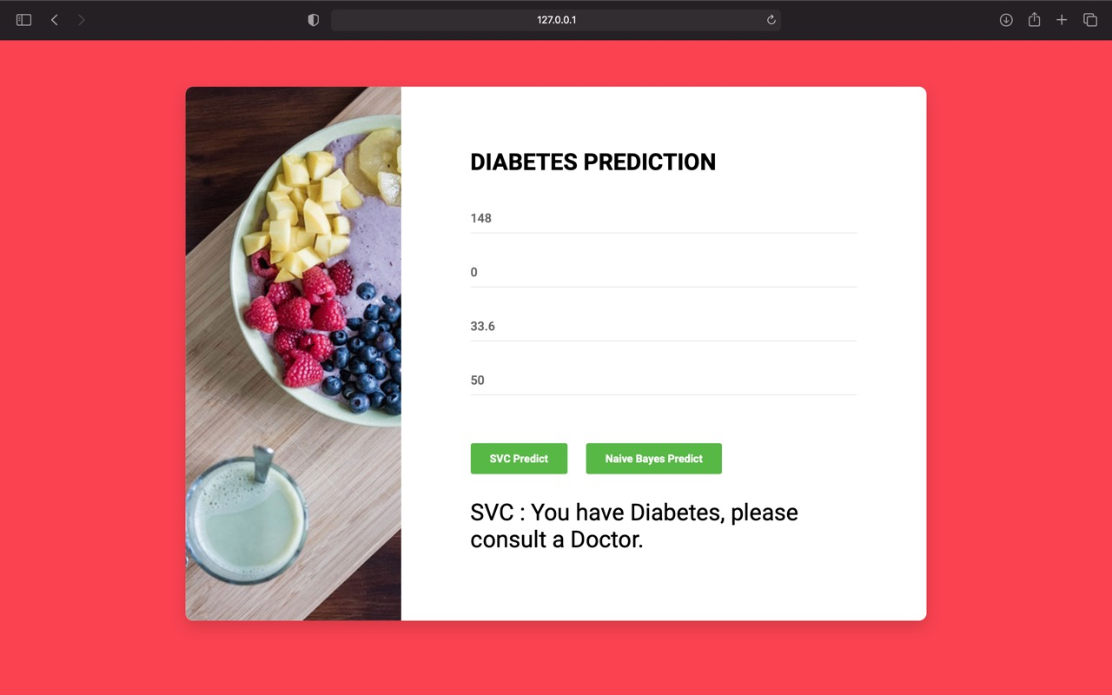

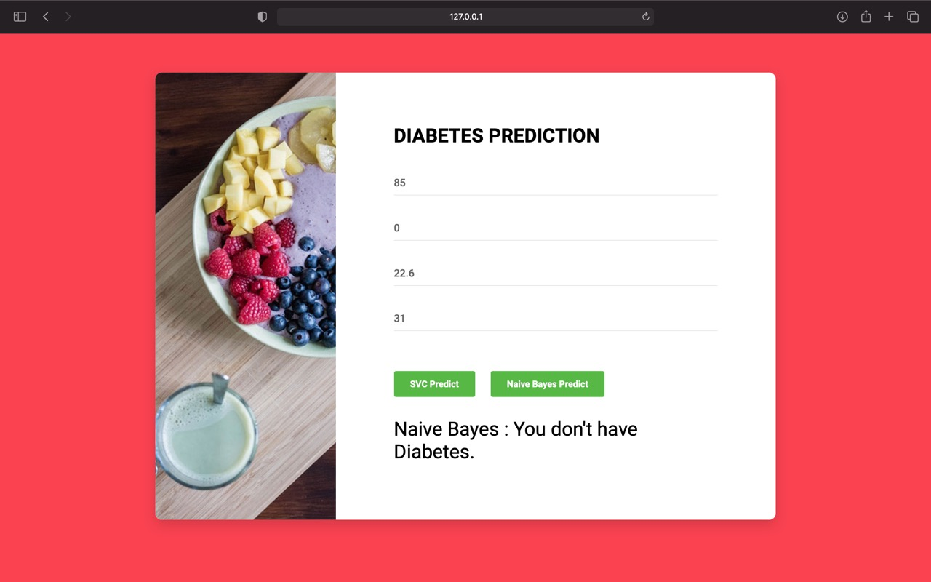

ALGORITHM

4.1 K-Nearest Neighbour

k-NN is a type of classification where the function is only approximated locally and all computation is deferred until function evaluation. Since this algorithm relies on distance for classification, if the features represent different physical units or come in vastly different scales then normalizing the training data can improve its accuracy dramatically
.
Both for classification and regression, a useful technique can be to assign weights to the contributions of the neighbors, so that the nearer neighbors contribute more to the average than the more distant ones. For example, a common weighting scheme consists in giving each neighbor a weight of 1/d, where d is the distance to the neighbor.

The neighbors are taken from a set of objects for which the class (for k-NN classification) or the object property value (for k-NN regression) is known. This can be thought of as the training set for the algorithm, though no explicit training step is required.

A peculiarity of the k-NN algorithm is that it is sensitive to the local structure of the data.

4.2 NAIVE BAYES

It is a classification technique based on Bayes’ Theorem with an assumption of independence among predictors. In simple terms, a Naive Bayes classifier assumes that the presence of a particular feature in a class is unrelated to the presence of any other feature.

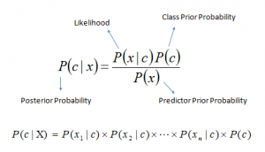

P(c|x) is the posterior probability of class (c, target) given predictor (x, attributes).
P(c) is the prior probability of class.
P(x|c) is the likelihood which is the probability of predictor given class.
P(x) is the prior probability of predictor.

Naive Bayes learners and classifiers can be extremely fast compared to more sophisticated methods. The decoupling of the class conditional feature distributions means that each distribution can be independently estimated as a one dimensional distribution. This in turn helps to alleviate problems stemming from the curse of dimensionality.

TESTING

Unit Testing:
Unit testing is a software testing method by which individual units of source code are tested to determine whether they are fit for use.

Selenium is one of the most popular automation testing tools. Here automation testing is a process of converting any manual test case into the test scripts using automation tools such as Selenium.

For our testing purpose, we are creating our sample test script using selenium tool in python programming language.

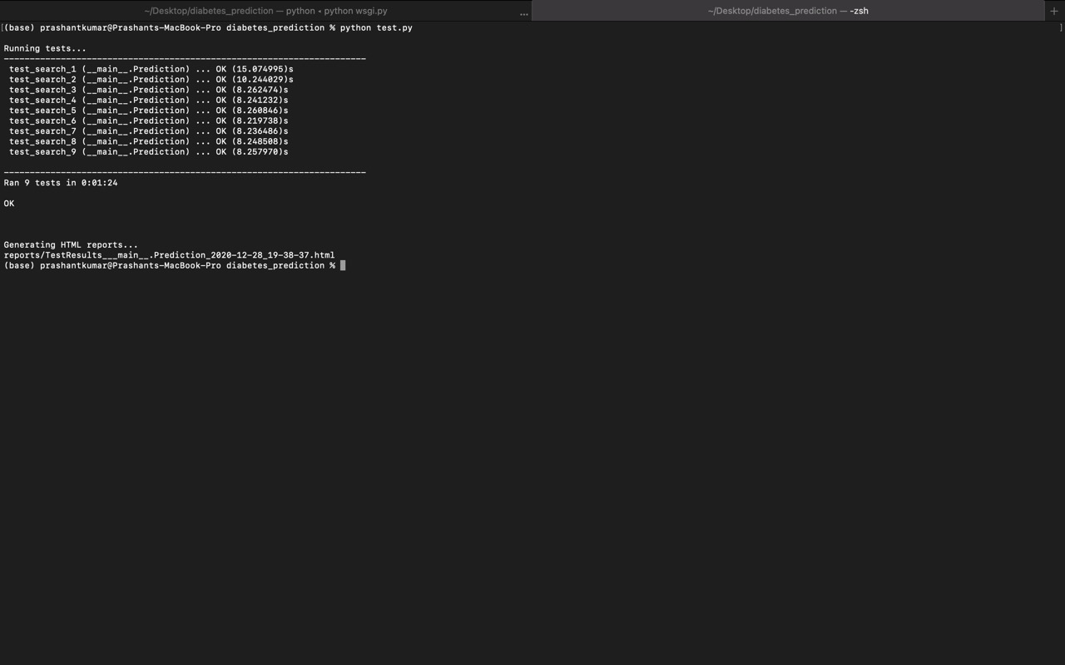

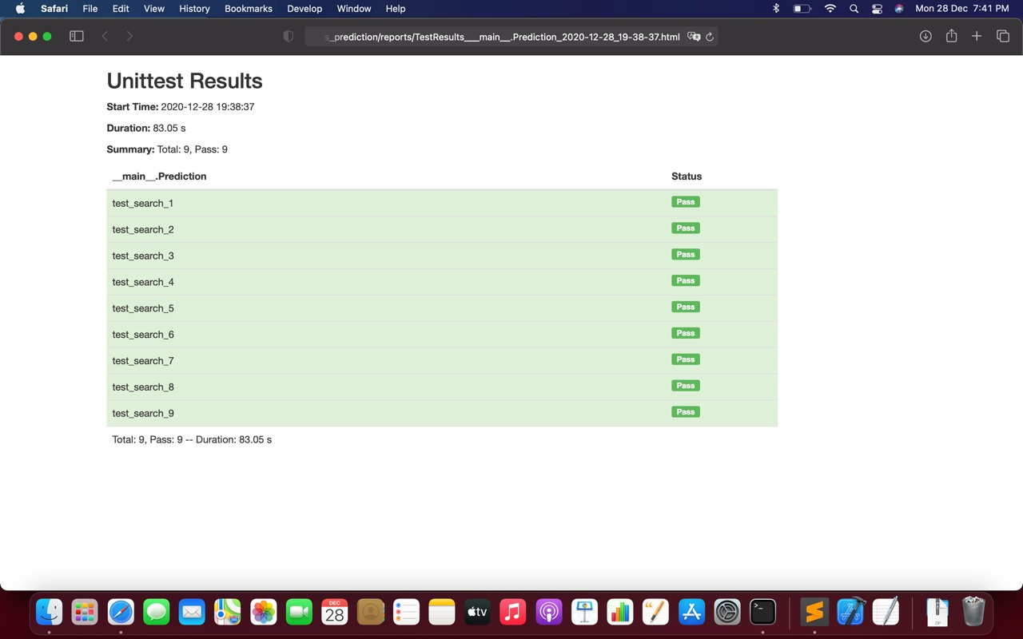

CONCLUSION

Data sets are extracted from health reports of various diabetic patients. These train datasets are given as input to the machine learning algorithm. The prediction algorithm predicted the diabetes for given sample datasets as well as error rate. The prediction efficiency of K-Nearest neighbour for sample datasets is 74%. Hence we conclude that similar models can be used to
predict other diseases like breast cancer, malaria etc.

REFERENCES

- Dataset:
https://www.kaggle.com/uciml/pima-indians-diabetes-database

- K- Nearest Neighbour Algorithm:
https://www.javatpoint.com/k-nearest-neighbor-algorithm-for-machine-learning

- Jothi, Neesha, and Wahidah Husain. "Data mining in healthcare–a review." Procedia Computer Science 72 (2015): 306-313

- https://en.wikipedia.org/wiki/Data_mining

